**Assignment 25.6**

Displaying database:-

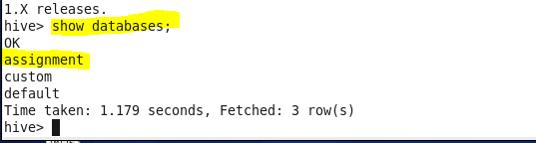

Creating table:-

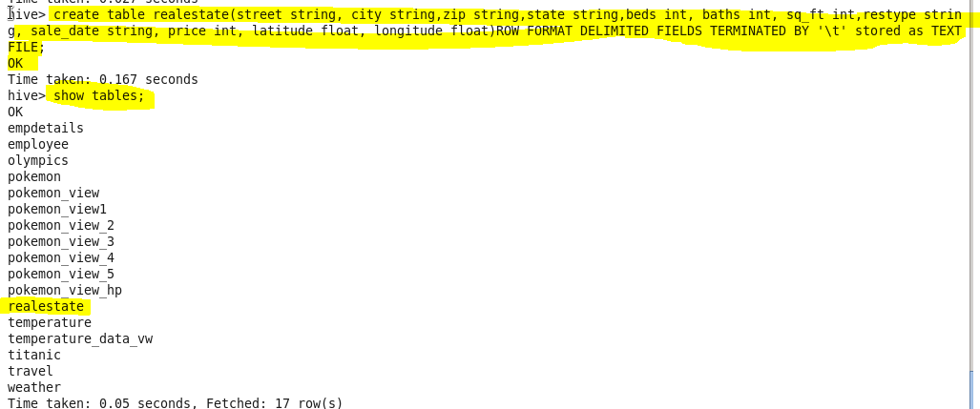

Loading data:-

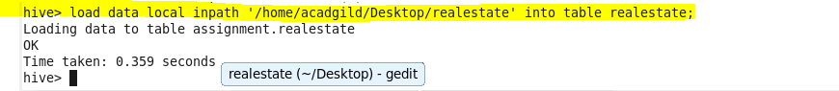

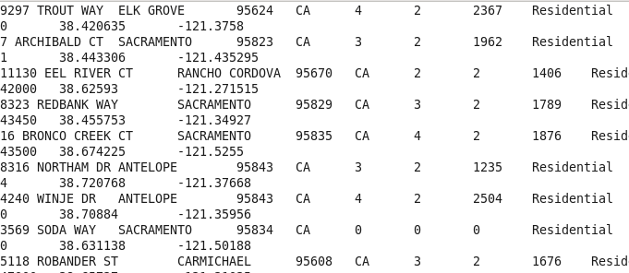

* **Write a hive query to find the city wise list all the Condos which is not less than ten thousand.**
* Since we want city wise list of all condos which is not less than ten thousand hence we will select city and filter by type equal to condos and price greater than 10000

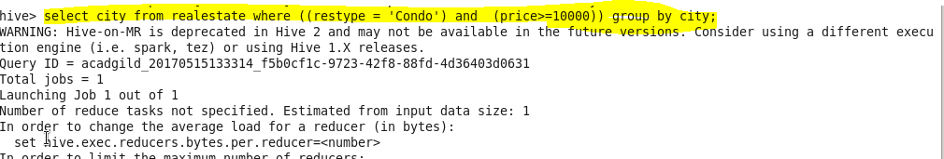

**Output:-**

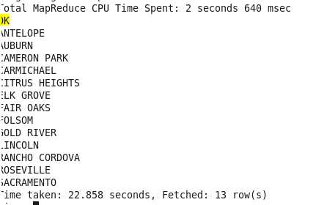

* **Write a hive query to find which is the cheapest Condo in CA. name the city,street and price for the Condo.**

Since we want cheapest condo in CA I will filter by state equal to CA using where condition and order the price and limit by 1 to get the minimum price as by default order will be in ascending order.

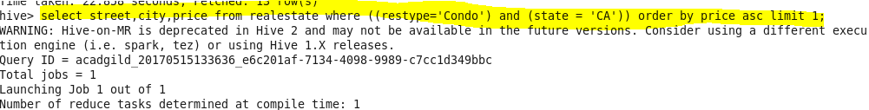

**Output:-**

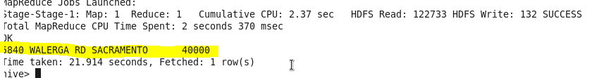

* **Write a hive query to list top 5 residency details which lie in the budget of 60000-120000, an area more than 1450, sold after 17th may, min bedroom 3 and, min bathroom 2.**

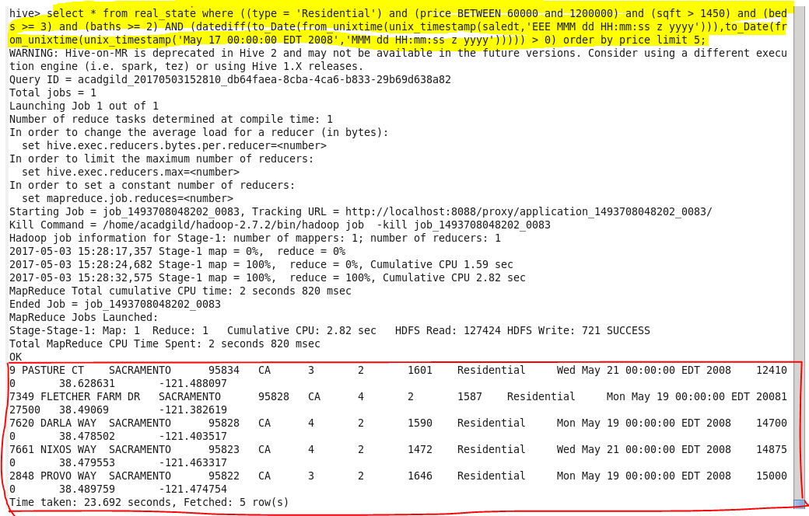

* **Write a hive query to separate list of residential apartments with more than 2 beds. Also include columns in following order City,Baths,Sq_feet,Price,flat_type,Beds respectively.**

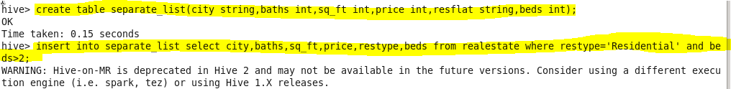

**Output:-**

